



















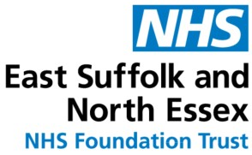






Is the person in their last year of life?
Start

Dependency End of Life Guidance

Accident and Emergency/Wards
Mental Heath Liaison

YES

https://www.spict.org.uk/

NON-COMPLEX
palliative care or
dependency needs?
COMPLEX
palliative care or
dependency needs or in the
last weeks or months of life?

Mental Health Liaison
If in the community, refer to SinglePoint - St Helena Including Community Palliative Care
01206 890360
Enter onto
My Care Choices Register
Primary Care Network
PCN

YES YES
NO
https://www.spict.org.uk/
If in ESNEFT, refer to Specialist Palliative Care 01206 746272 or via Ordercomms
If in the community, refer to SinglePoint - St Helena Including Community Palliative Care
01206 890360

Specialist Treatment and
Recovery Service (STARS) - prescribing service
01206 228746
Phoenix Futures 01376316126 (psycho-social interventions)

Stars - 01206 228746
Stars - 01206 228746
Open Road - 0844 4991323
Open Road - 0844 4991323
Carers First phone number is 0300 3031555
Young carers support through Essex County Council Tel Social
care connect on 0345 6037630
Alcohol Liaison Nurse EPUT Specialist Nurse

Phoenix Futures 01376316126
Phoenix Futures 01376316126

