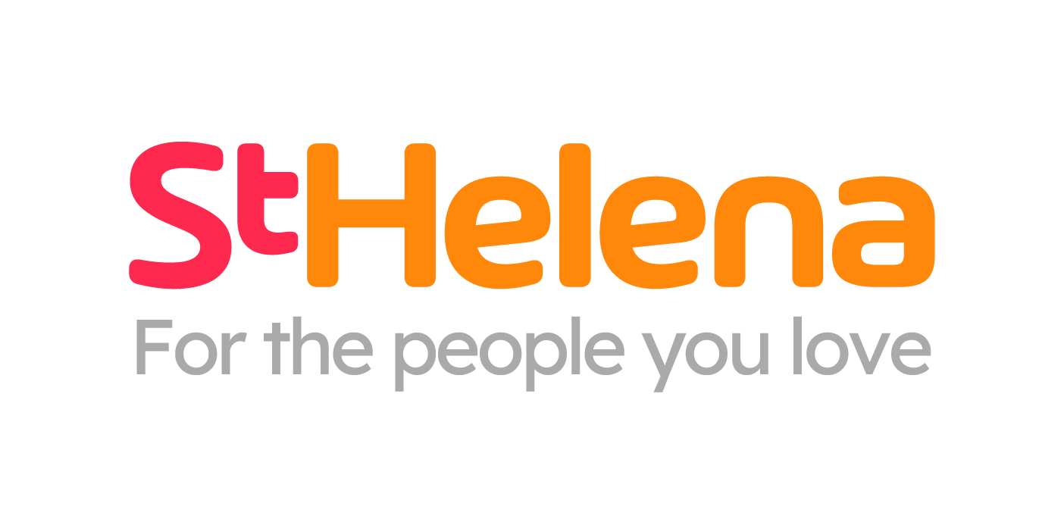

Helping local people face incurable illness and bereavement, supporting them, their families, friends and carers.

Recruitment pack
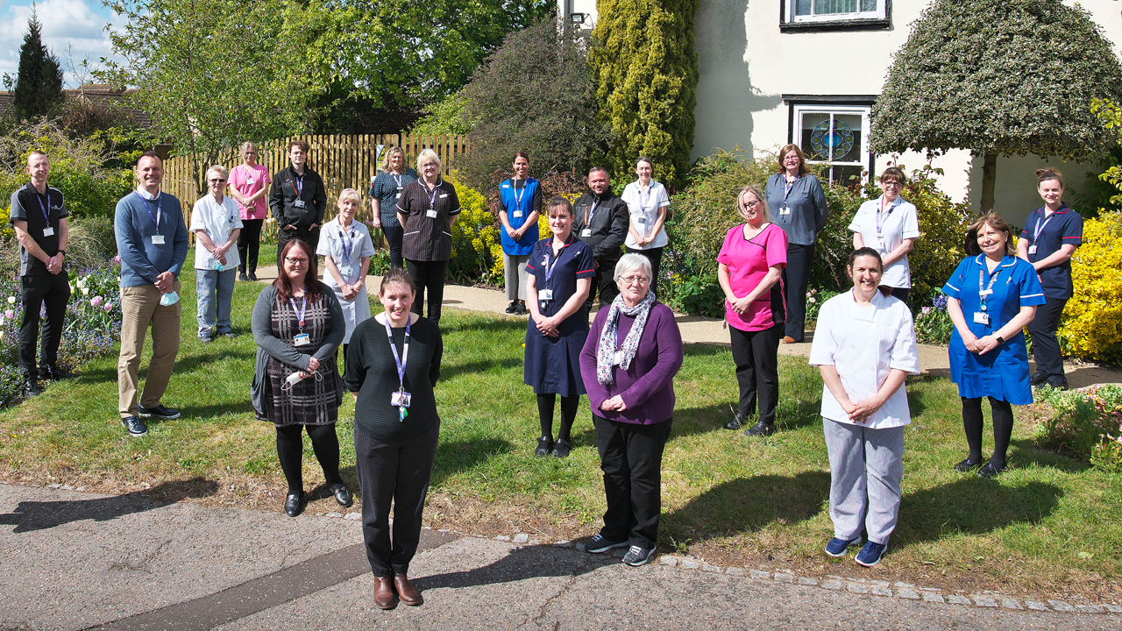
Staff Nurse - Nights

Who is St Helena?

Here at St Helena, we believe that everyone living with an incurable illness has the right to live and die with choice, compassion and dignity. Families deserve to be cared for and anyone coping with loss should be supported through their grief.

Our vision is to create a community where everyone knows that as the end of their story draws near, they will be cared for and die where they choose to be; where loved ones have the opportunity to make the most of life together, surrounded by people who care and support one another.

Since we opened in 1985, this belief drives us to provide the best end of life care and bereavement support to everyone in north east Essex, not just today but for years to come.

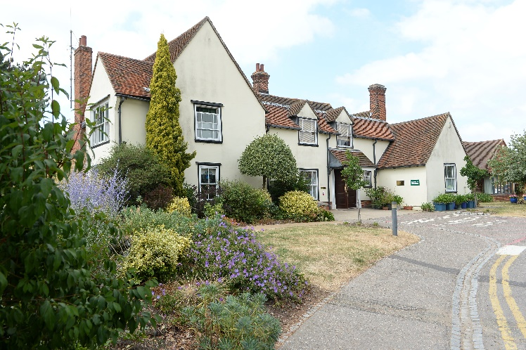

Every year we support more than 4,100 local people facing dying, death and bereavement.
By focusing on their physical, emotional and spiritual needs, we aim to bring comfort and relief to all those who need it, offering the people of north east Essex individual care and total support, regardless of their diagnosis or personal circumstances.
By visiting them in their homes, over the phone with our 24/7 advice line, and at the Hospice in Colchester, through all the smiles and all the tears we guide those who need us, because we believe in making every memory matter.
Not only do we support local people in our community facing incurable illness, but we also support adults and children living in north east Essex through bereavement, regardless of how or where their loved one died.
St Helena is an independent charity, providing our services free of charge. The equivalent of 7 out of 10 of the patients and families we care for and support are funded by people in our local community giving donations, buying from our shops, playing our lottery and leaving gifts in Wills.
We rely on the help and generosity of our fundraisers, donors and volunteers to continue to provide our services. Without them we wouldn’t be here.
What does the role entail?

Place of work | St Helena, Myland Hall, Colchester
Salary | £29,970 to £35,099.41 (Depending on experience)
Contract type | Permanent
Reports to | Senior Ward Sister / SinglePoint CNM
Travel | Yes

JOB DESCRIPTION

JOB OVERVIEW
JOB TITLE | Staff Nurse /Paramedic – Nights only
DEPARTMENT | Hospice MDT and Hospice in the Home MDT
LOCATION | Colchester
REPORTS TO | Senior sisters HIH and IPU

KEY WORKING RELATIONSHIPS
- Hospice and Hospice in the Home Matron  - Hospice and Hospice in the Home Multidisciplinary Team  - Primary Care Services  - Community Teams  - Patients and families  - Volunteers | The post holder will be accountable to the Director of care for performance in relation to professional practice.
KEY PRIORITIES
- Work as part of the hospice MDT and Hospice in the home MDT
- Provide high standards of specialist palliative care to patients and their relatives, including assessment, planning, implementing, and evaluating care needs.
- Organise day to day work tasks and direct less experienced or junior colleagues. Ensure that patient safety is always maintained.
- Act as an advocate for patients as required.
- Triage calls over 24 hours and giving advice and support to patients who are known to St Helena or have their details recorded on the My Care Choices Register.
- Provide rapid response visits to patients in crisis in the community.
- Effectively manage time to meet the needs of patients.
- Be a clinical resource to Health Care assistants as well as Administrators and Call Handlers.
- Work closely with community and primary care colleagues, St Helena and hospital staff to ensure that patients requiring end of life care receive an integrated service in a timely manner.
- Working overnight, either in the Inpatient unit or taking calls in SinglePoint from patients, family members and professionals and undertaking home visits as necessary throughout North East Essex.
- Ensure you have a current driving licence and access to a vehicle.

DUTIES & RESPONSIBILITIES
Hospice MDT

- Participate as a member of the inter-disciplinary team in assessing, planning, implementing, evaluating care and meeting the needs of patients: hygiene, elimination, nutritional, mobilising, pain, maintaining independence. Work as part of a team to provide psychological, emotional, spiritual and social support to patients and families whose lives are affected by illness, loss and grief.
- Lead the admissions and discharges.
- Provide care after death to deceased patients including safe custody of valuables and belongings.
- Maintaining health & safety within the ward area i.e. ensure fire exits are clear, cupboards safely stocked & hazards removed and reported.
- Ensure that all medication is administered in accordance with St Helena policy, NMC or HPCP regulations.
- Support bereaved families with next steps and signposting .

Hospice in the Home MDT

- To act as a resource to patients and their families in the community, providing telephone advice and support.
- To provide a rapid response visit to patients with urgent palliative or end of life care needs.
- To be responsive to changing patient needs and flexibly visit according to suggested triaged response time.
- To work shifts including overnight, triaging calls and visiting patients as necessary, often as a lone worker.
- To maintain and promote effective and efficient working and communication with other community professionals, hospital professionals, voluntary, private, and statutory agencies and other hospices.
- Demonstrate effective communication with patients’ key workers to ensure continuity of care for patients across all sectors.
- Act as co-worker for patients providing effective communication with keyworkers in order to ensure continuity of care for patients across St Helena services.
- Demonstrate effective communication with patients’ key workers in order to ensure continuity of care for patients across all sectors.

Hospice in the Home and Hospice MDT

- Provide effective communication with keyworkers in order to ensure continuity of care for patients across St Helena services.
- Develop awareness of emotional needs of patients and families and the sensitivity and communication skills to meet these needs.
- To communicate sensitively and effectively both verbally and in writing with patients, families and colleagues including volunteers. In some cases, there may be barriers to understanding or highly sensitive communication required.
- Act as an advocate for patients where required.
- Ensure that all medication is administered in accordance with St Helena policy, NMC or HPCP regulations.
- To verify death following training and when it is appropriate to do so in line with St Helena policy
- Ensure patient records are accurately written, in line with NMC and St Helena regulations, (i.e. patient records incident/accident reports, computer records).
- Ensure Infection Control Policies and Procedures are strictly adhered to.
- Check and ensure that equipment is clean and in working order ready for use.
- Supervise, healthcare assistants this will include addressing areas of poor practice.
- Raise any safeguards concerns whilst adhering to the St Helena safeguards policy.
- Adhere to St Helena values and act as a role model.
- You should be flexible and adaptable to changes in your duties depending on patient demand, staffing levels and operational priorities. For this role a willingness to support colleagues and work collaboratively across the wider team is essential to meet the needs of the service. The postholder will continue to undertake a range of duties within the scope of the role; these responsibilities will be carried out across both the Inpatient Unit and Community Services, as required by service needs. All reasonable efforts will be made to provide notice of any changes to usual working patterns, in line with organisational policy.

Education

- Attend mandatory training as required by St Helena
- Complete competencies within 18 months of joining St. Helena
- Participate positively in Clinical Supervision in order to develop standards of clinical practice and for support.
- Demonstrate and share continued professional practice development.
- Participate in the audit process and ensure that practice is evidence based.
- Assist in the identification and meeting of educational needs of other staff.

GENERAL - Applicable to all roles at St Helena
All of the above activities are governed by the operational policies, Standing Financial Instructions, policies and procedures and standards of St Helena as well as legislation and professional standards and guidelines.
All employees must comply with St Helena’s Equal Opportunity Policy and must not discriminate on the grounds of sex, colour, race, ethnic, or national origins, marital status, age, disability, sexual orientation or religious belief.
Employees have a responsibility to themselves and others in relation to managing risk, health and safety and will be required to work within the policies and procedures laid down by St Helena. All staff have a responsibility to access occupational health; other staff support services and/or any relevant others in times of need and advice.
All employees have the right to work in an environment which is safe and to be protected from all forms of abuse, violence, harassment and undue stress. All employees are responsible for helping to ensure that individuals do not suffer harassment or bullying in any form. All employees will be personally accountable for their actions and behaviour in cases of complaints of harassment or bullying.
St Helena is a smoke free organisation. Smoking is not allowed in any St Helena premises. If you would like help to give up smoking, you should contact your GP or call the NHS Stop Smoking Help Line.
St Helena is a charity, and all staff are responsible to ensure that funds are spent in the most sustainable and efficient way. Staff may also be encouraged to join fundraising and other business-related activities to promote the charity’s financial well-being.
PERSONAL DEVELOPMENT
Be aware of own development needs and take appropriate action. Keep updated of evidence-based practice and government policies related to care. Act as an effective role model at all times.
PROFESSIONAL DUTIES
To maintain personal professional status, ensuring that the requirements laid down by the relevant professional body for registration are compliant.
Exercise professional accountability as guided by the relevant professional body and maintained in accordance with the policies of the department and St Helena.
ANNUAL APPRAISAL
The post holder will be appraised on an annual basis and the process will include a review of the past year’s performance, setting of aims and objectives for the coming year and identification of educational needs.
TRAINING
All staff will undertake such training as is necessary to perform the duties allocated and any mandatory requirements of St Helena. This will include mandatory training in line with your job role.
QUALITY
St Helena aims towards maintaining the goodwill and confidence of its own staff and of the general public. To assist in achieving the objective it is essential that at all times, employees carry out their duties in a courteous and sympathetic manner.
CONFIDENTIALITY
Your attention is drawn to the confidential nature of information collected and used throughout the NHS. The unauthorised use or disclosure of patients, staff or other personal information is a dismissible offence. The unauthorised disclosure of information could also result in prosecution for an offence, or action for civil damage, under GDPR.
SAFEGUARDING CHILDREN AND VUNERABLE ADULTS
All St Helena employees are required to act in such a way that at all times safeguards (and promotes) the health and well-being of children and vulnerable adults. Familiarisation with and adherence to St Helena safeguarding policies is an essential requirement of all employees as is participation in related mandatory/statutory training.
VALUES AND BEHAVIOURS
St Helena’s core values and behaviours will be embedded in our recruitment, training and development review and decision-making process.
Bold | In an ever-changing world, we have the confidence and determination needed to innovate, stand out from the crowd, and make a real difference every day.
Passionate | We love what we do, and we are committed to our cause because it means everything to the people in our community who need our help.
Caring | People will always come first at St Helena. Everyone  is welcome and everyone will be looked after as though they are a part of our extended family.
This job description is not an exhaustive document but is a reflection of the current position. Details and emphasis may change in line with service needs and after consultation with the postholder.

PERSON SPECIFICATION

ATTIRIBUTE | ESSENTIAL | DESIRABLE
Qualifications | - RGN/RMN  - Paramedic | - Willingness to improve knowledge and skills within palliative care.
Experience | - Proven experience as a registered nurse/ paramedic  - Experience of handling difficult situations | - Experience of working with people with mental health needs • Experience of working with people with sensory and learning disabilities  - Experience of working in the community
Skills & Knowledge | - Proven awareness of the possible needs of patients, families under the care of St Helena  - Ability to recognise and respond to potential distress in individuals and to manage crisis situations.  - Full Driving Licence (and access to a vehicle) | - Understanding of the interface between community and acute settings  - An awareness of St Helena as an organisation and the services it provides  - Knowledge of illness as a carer and the ability to recognise when a person has physical, social, psychological or spiritual care needs
Communication | - Proven written and verbal communication skills.  - Clear verbal communication skills demonstrable with a range of people.  - • Ability to accurately record any information required i.e. patient records, telephone messages or information as requested by | - Skills in communicating with people with specific communication needs including learning disabilities and sensory disabilities
Qualities | - Proven ability to work off own initiative and as part of a team.  - Flexible to meet needs of service.  - Physically able to undertake the job. Proven coping strategies when under emotional pressure  - Proven ability to manage time effectively  - Proven ability to problem solve.  - Role model who can influence, motivate, and encourage others. | - Innovative and creative

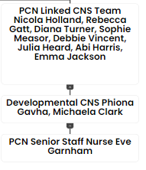
Meet some of the team

Nicky Coombes - Hospice in the Home
I qualified as a nurse in Eastbourne in 1999 and moved back to Essex in 2004
I joined St Helena hospice as a developmental hospice nurse specialist in 2010 and eventually became a fully-fledged hospice nurse specialist completing my palliative care degree. I was in this role for a few years and decided to change roles to referrals clinical nurse specialist, when SinglePoint was first established. I was in the role for 5 years and decided to take on a new challenge and left the hospice for 10 months to work for the J’s which was a hospice that supported young adults.
I returned to St Helena at the beginning of 2021 and took on the role of Matron for hospice in the home MDT. My passion and focus has been palliative care over the last 12 years.
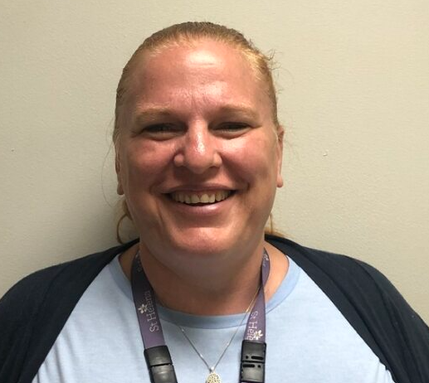


Our values are incredibly important to us. But at St Helena, values are much more than just words…
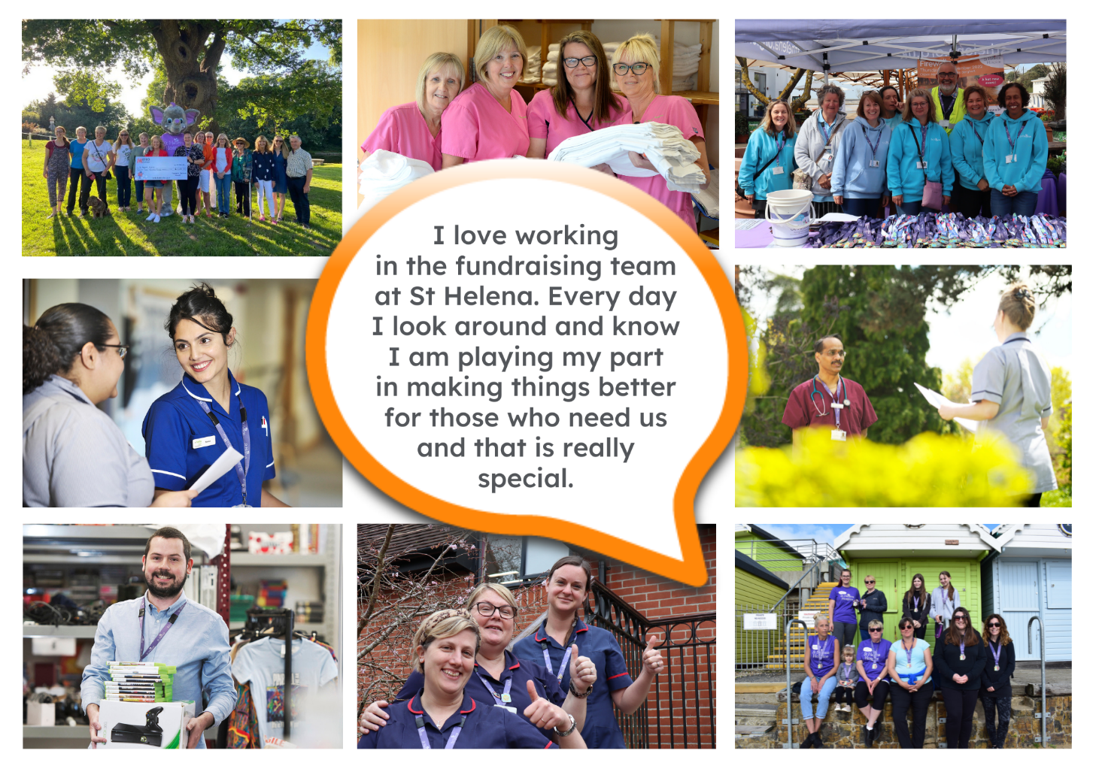
They are feelings….
“It takes an amazingly special place with exceptionally special people to make the hardest times of your life turn into the most precious and so full of love.”

The passion
Whether you work within the clinical team, one of our support services or in the commercial team, each and every team member is incredibly passionate about what they do.
Working for St Helena is a privilege. There’s not many companies you could work for that really make a difference to the local community as St Helena does.
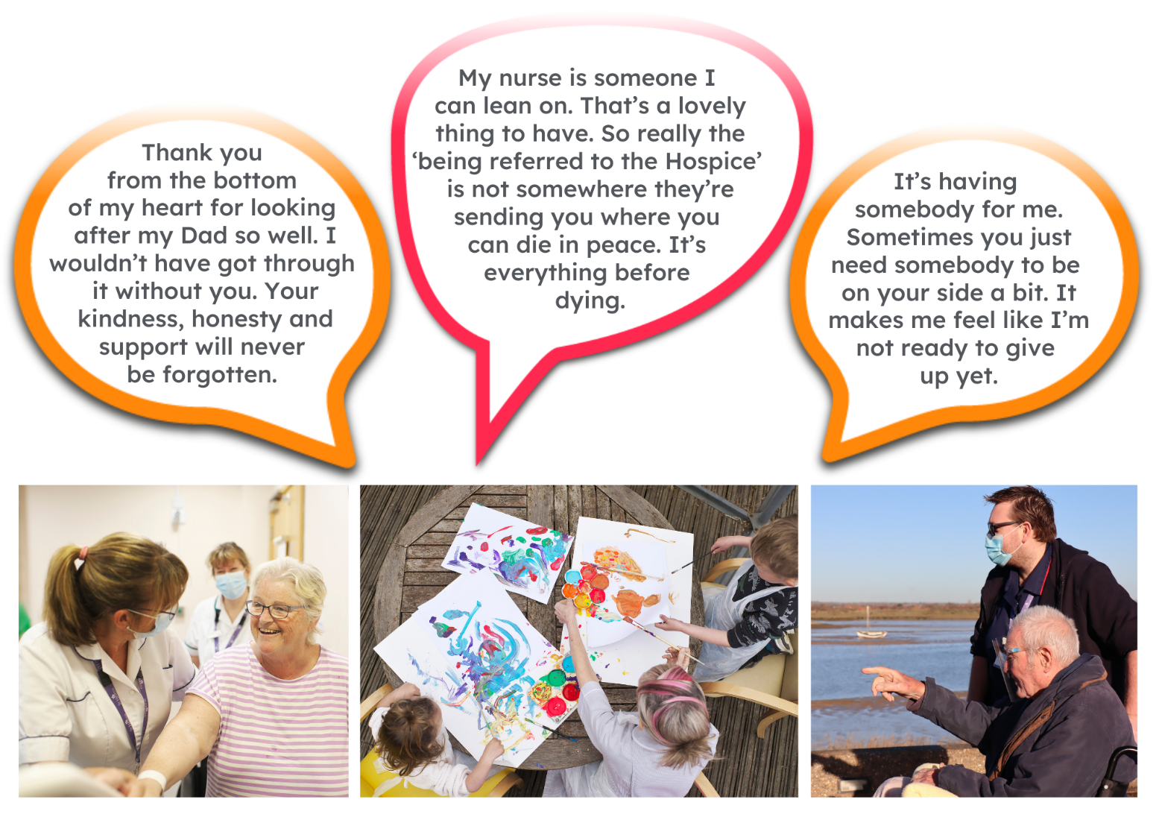
This isn’t just a belief held by those working here; it’s feedback we often receive from the patients and families we support:
Can you really make a difference?

- Last year, we helped 4,171 patients and families facing incurable illness and bereavement. More than we have ever supported before!

- 47,421 calls were made to our SinglePoint 24/7 phoneline.

- £585,058 was raised from local individuals, groups, schools and businesses in the community.

- None of this can be achieved without our amazing team. Everyone plays a part!

The benefits
Not only is working at St Helena rewarding, there are a huge amount of benefits too!
Next steps
We hope we’ve given you a bit of an idea of what an amazing place St Helena is to work and you’re keen to find out more!
Here are the next steps:
- To find out more about St Helena, please visit our website www.sthelena.org.uk

- Apply for the position!

- Please contact us on the details below if you have any questions before or after you apply, we’ll be happy to talk through!

- Follow us on social media @StHelenaHospice to keep in the loop!

We look forward to meeting you!

Contact us:
For more information about the role please contact Nicky Coombes, Matron on recruitment@sthelena.org.uk

Registered Charity Number 280919. Registered Office: Myland Hall, Barncroft Close, Highwoods, Colchester, CO4 9JU

